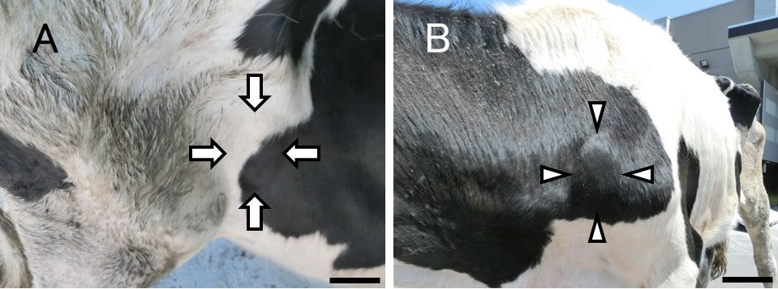
Fig. S1. (A) Right subiliac lymph node (arrow) and (B) left superficial cervical lymph node (arrow head) were enlarged on day 4. Bar = 10 cm.
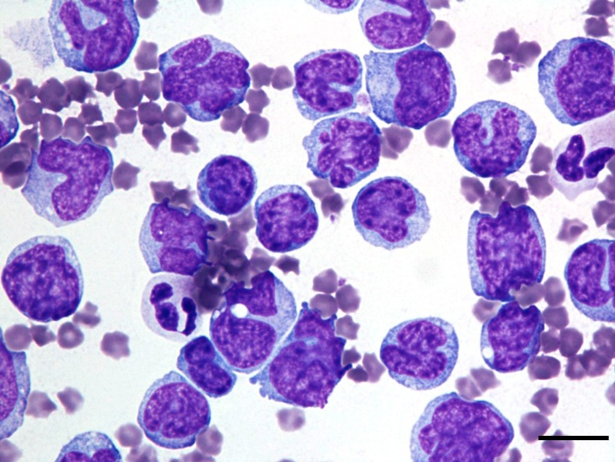
Fig. S2. Smear examination of peripheral blood. More than 90% of lymphocytes were morphologically atypical with wide cytoplasm, fine nuclear chromatin, and nucleoli. Wright-Giemsa stain. Bar = 10 μm.

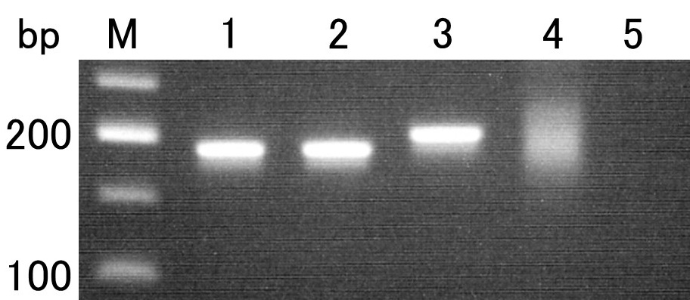
Fig. S3. PCR of immunoglobulin heavy chain gene variable region. Lane 1: DNA from blood; Lane 2: DNA from lymph node tissue obtained by FNA; Lane 3: positive control (typical EBL); Lane 4: negative control (lymphadenitis); Lane 5: negative control (DW); M: molecular weight marker.
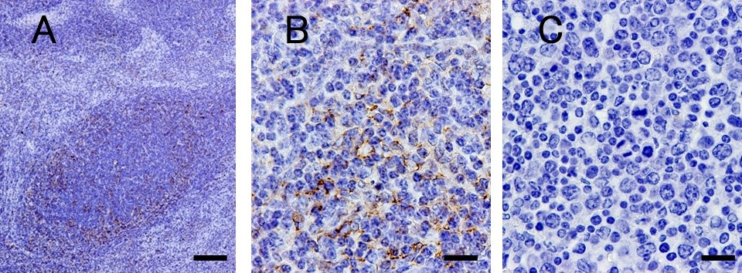
Fig. S4. Immunohistochemistry of BLA-36 controls. (A) and (B): Lymph nodes of a healthy cattle were stained with BLA-36 as positive control. B cells in lymphoid follicles were stained. Bar = 200 μm and 20 μm. (C): Subiliac lymph nodes were stained with PBS as negative control. The non-specific reaction was not stained. Bar = 20 μm.

